**Spectral Bandwidth:**

**The spectral bandwidth value provides an indication of how spread out the frequencies are in the spectrum. A larger bandwidth suggests a wider range of frequencies, while a smaller bandwidth indicates a narrower range.**

* **Noise and Distortion Analysis:** Spectral bandwidth may be useful in identifying and analyzing noise and distortions in audio signals. Wide spectral bandwidth in certain frequency regions can indicate the presence of noise, while narrow bandwidths may indicate the presence of harmonic components. So, we can use this difference.
* **Speech Processing:** In speech analysis, spectral bandwidth can provide information about the spectral characteristics of different phonemes or speech sounds.
* **Sound Source Separation:** Spectral bandwidth can be employed in sound source separation algorithms to distinguish between sound sources based on their frequency spread besides other powerful audio features.

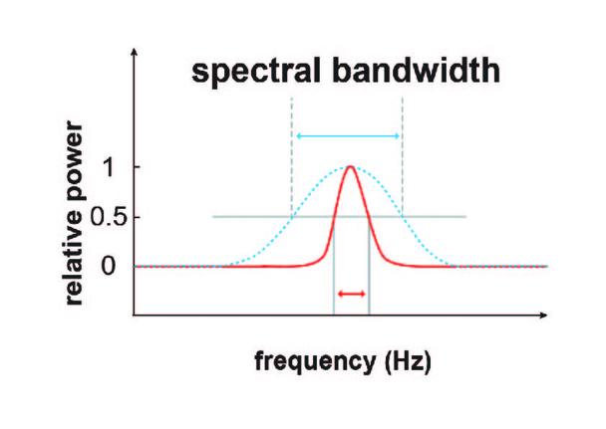

It is a feature in audio and signal processing that measures the spread or width of frequencies present in an audio signal’s spectrum. It complements the information provided by the spectral centroid.